Instructions - SoE Work Safety Assessments
Read full instructions on how to complete your WSA

Works best if opened in desk top app.

SoE Work Safety Assessments

Declaration
As the Work Leader I believe so far as is practicable that:
☐ The following Work Safety Assessment (WSA) Overview and related WSA Supplements are correct.
☐ The hazards involved in this work have been identified in the following WSA Supplement(s):
Select Supplements that have been completed:
 | Name | Completed Yes/No
1 | Work Safety Assessment Overview
2 | WSA: Chemical Hazards
3 | WSA: Plant & Physical Hazard
4 | WSA: Fieldwork & Off-Campus Activities
5 | WSA: Biological Hazards
6 | WSA: Radiation Hazards
7 | WSA: Nanomaterials
☐ Adequate hazard control measures have been identified in the WSA Supplement(s) indicated and have or will be implemented and used. Adequate training will be undertaken and the work will be carried out under appropriate supervision.

Outline changes to previous WSA here: (if applicable)

If you are updating a previously approved WSA please briefly outline below the changes made (refer to relevant sections or provide brief description of the changes made)

Work Safety Assessment Overview

Instructions
Completion and approval of this form is the key way for Deakin University to be assured that a Researcher/Student is aware, trained and adequately supervised in their specific work’s requirements for hazard identification, risk assessment and the implementation of hazard control measures.

Project Information
Work Supervisor/Manager: (i.e. Principal Researcher supervising work)
Work Leader name and position (e.g. Hons student): (i.e. Lead Researcher
performing work)
Additional Work Participant(s), name (If applicable):
Primary Campus or Location for Work/Unit:
Work Start Date: |  | Estimated Work End Date:

Summary of work
Provide a brief summary of the proposed work, using plain language with non-scientific terms. In addition, list potential hazard areas that will need to be addressed (e.g. radiation, microorganisms, chemical hazards, fieldwork, physical hazards, nanomaterials).

Identification of Hazard Categories
Check the relevant boxes below to identify the hazard categories of the proposed work.

Chemical hazards
Does your project involve the use of:
☐ Regulated substances (Scheduled medicines or poisons, scheduled carcinogens, Chemicals of Security Concern, drug precursor chemicals, explosives)
☐ Higher risk chemicals (Risk Category 4 and 5 chemicals) – complete Chemical risk assessment form to determine this.
☐ Use or synthesis of novel chemicals
☐ Large scale reactions
☐ Other chemical safety issue(s)
If any box is checked please complete the Chemical Hazards Assessment.

Plant, equipment and physical hazards
Does your project involve the use of:
☐ Power operated machinery (called plant)
☐ Repeated movement of objects
☐ Lifting of heavy objects
☐ Excessive or repeated noise or vibration
☐ Extreme heat or cold, molten materials
☐ Welding
☐ Other plant or physical hazard safety issue
If any box is checked complete the Plant & Physical Hazard Assessment

Fieldwork and off-campus activities
Does your project involve:
☐ Use of car, boat or trailer
☐ Work under hazardous conditions (e.g. aquatic environments, cliff faces, diving, remote locations, after hours)
☐ Exposure to extreme weather or environmental conditions (e.g. very low or high temperatures, blizzards in alpine areas, poor visibility)
☐ Handling of animals in the field
☐ Work carried out at workplaces not under the management of Deakin University (e.g. another university, research establishment, government institute, business)
☐ Travel or work overseas
☐ Other fieldwork safety issue
If any box is checked complete the Fieldwork and Off-campus Activities Hazard Assessment

Biological hazards
Does your project involve the use of:
☐ Human tissues, human blood or other body fluids
☐ Potentially pathogenic or pathogenic bacteria, fungi, viruses, protozoa or cell cultures
☐ Zoonotic microorganisms
☐ Genetic manipulation (OGTR)
☐ Use of imported biological materials (DAFF Biosecurity, formerly AQIS)
☐ Live animals or animal tissues, eukaryotic cells/cell lines
☐ Other biological safety issue(s)
If any box is checked complete the Biological Hazards Assessment

Nanoparticle hazards
Does your project involve:
☐ Use or procurement of nanomaterials
☐ Manufacture or synthesis of nanomaterials.
If any box is checked please refer to Guidelines for completing research application forms.

Radiation hazards
Does your project involve:
☐ Sealed or unsealed Ionising radiation sources
☐ Ionising radiation apparatus (excluding X-ray diffraction Units)
☐ Non-ionising radiation (Unguarded Class 3B or 4 Lasers, UV, IR, Radiofrequency)
☐ Strong magnetic fields (excluding NMR)
☐ Other radiation safety issue
If any box is checked complete the Radiation Hazard Assessment

Human Ethics
☐ Research involving human participants, use of identifiable personal records or use of stored human tissue (including blood samples)
If the box is checked Human Research Ethics Unit approval will be required. Refer to the Human Research Ethics website.

WSA: Chemical Hazards
Note: All Dangerous Goods (DG) or Hazardous Substances (HS) which enter Deakin University premises must have a Chemical Risk Assessment (located on SEBE HSW SharePoint) completed or be covered by a safe work procedure.
Regulations require the Manufacturer’s Safety Data Sheet (SDS) to be used for risk assessment - these can be accessed through the Chemwatch database or direct through Manufacturers’ websites.
Where materials have previously been assessed, new users must read and understand the assessments.
Is any portion of this work described in a standard procedure (e.g. SOP/SWP)?
☐ Yes
☐ No
If yes, please upload these to your project folder on the WSA SharePoint site as supporting documentation.

Section 1: Information about Chemical Hazards

Hazardous Chemicals
Provide a brief summary of the proposed work involving hazardous chemicals
Include details such as: laboratories the work will take place in, approximate quantities/volumes of chemicals to be used, processes or reactions to be performed and any specific hazards or risks.
Brief procedure
Chemicals being used
H number and phrase

Regulated Substances that may require Permits or Licenses:
Does the work involve the use of any of the following regulated substances:
☐ Scheduled 2, 3, 4, 7, 8 or 9 medicines or poisons?
Note: The University Poisons Guidelines provides compliance requirements.
☐ Therapeutic Goods (which may also be Scheduled Medicines).
Note: A comprehensive list of therapeutic goods is available from the Australian Register of Therapeutic Goods.)

☐ Class 1 (Schedule 10) or Class 2 (Schedule 11) Carcinogens.
Note: See WorkSafe Victoria for the full list of scheduled carcinogens
☐ High Consequence Dangerous Goods (HCDGs)? (ammonium nitrate & calcium ammonium nitrate in concentrations > 45% ammonia).
Note: See WorkSafe Victoria for more information.
☐ Chemicals of Security Concern (CSC)?
Note: This list consists of 96 chemicals, including common solvents and acids/bases. Check at the Australian National Security website.
☐ Explosives (DG Class 1).
Note: Small amounts of explosives are allowed to be held and used for research purposes. More information should be obtained from Worksafe Victoria Explosives

You will be asked to provide details under Higher Risk Chemicals

Drug Precursor Chemicals and Apparatus Declaration
Precursor chemicals and apparatus are items that are known to have been used in the illicit manufacture of drugs. They are also regulated under the Drugs, Poisons and Controlled Substances Act. More information can be found in the University Precursor Supply Guidelines.
By submitting this WSA, you are declaring that you will only use chemicals and apparatus for the purposes described in this document.
Tick the box to indicate that you have read and agree to this statement.
☐ I have read and agree to this statement.

Higher Risk Chemicals
List any Risk Category 4 or 5 chemicals and all regulated substances which will be used in this project in the table below and fill in the required information.
Upload all risk assessments, SDS's and Safe Work Procedures as supporting information.
Refer to the chemical risk assessment instructions for guidance.
 | Chemical name | DG Class | DG subclass | Risk category  (4 or 5)  Risk Category will come from the Chemical Risk Assessment | Is the chemical a regulated substance?  Please specify what category (refer to regulated substances that may require permits or licenses) | Overall Risk Rating
1 |  | Choose an item. | Choose an item.
2 |  | Choose an item. | Choose an item.
3 |  | Choose an item. | Choose an item.
4 |  | Choose an item. | Choose an item.
5 |  | Choose an item. | Choose an item.
6 |  | Choose an item. | Choose an item.
7 |  | Choose an item. | Choose an item.
8 |  | Choose an item. | Choose an item.

Novel Chemicals:
If there will be novel chemicals associated with this project, how will you be obtaining them?
☐ Synthesised by project team
☐ Synthesised by internal (Deakin) collaborators
☐ Synthesised by external collaborators
☐ Other (please specify)
Novel Chemicals synthesised by the project team
Please search the Australian Industrial Chemicals Introduction Scheme (AICIS) website to determine if your products are considered ‘novel’ and if there are any regulations on manufacture. Please note that as a manufacturer/supplier you will be under obligation to provide safety documentation (e.g. SDS, labels) for synthesised materials – please discuss with the Health and Safety Team.

Provide details here:
Will you be providing the synthesised compounds to other collaborators (within or external to the institute)?
☐ Yes
☐ No
If yes please provide details. Who you will be supplying to? If known: approximate quantities, structures, hazardous substance etc.

Novel Chemicals synthesised by collaborators:
Please provide details (who is the supplier? If known: approximate quantities, structures, hazardous substance? Etc.)

Large Scale Reactions:
Refer to the table below for definition of ‘large scale’.
Class 2.1 Flammables Gases | H220, H222, H223 | 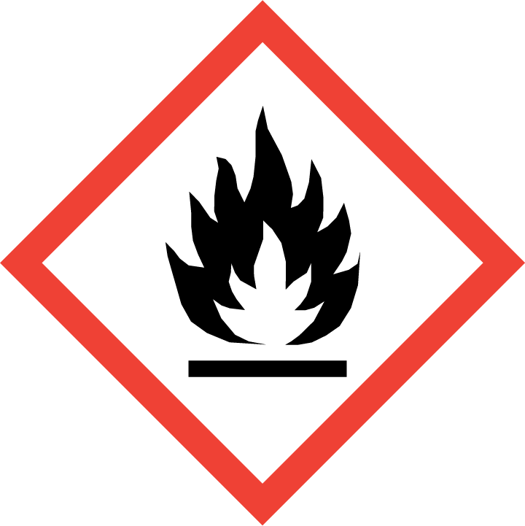 | 1.25 kg or 0.25m³ | Hydrogen, LP Gas, Acetylene
Class 2.2 Compressed Gases | H280 |  | 1.25 kg or 0.25m³ | Nitrogen, Argon
Class 2.2 Cryogenic Gases | H281 |  | 1.25 kg or 0.25m³ | Liquid Carbon Dioxide, Nitrogen, Argon
Class 2.2 SubRisk 5.1  Oxidising Gases | H270 | 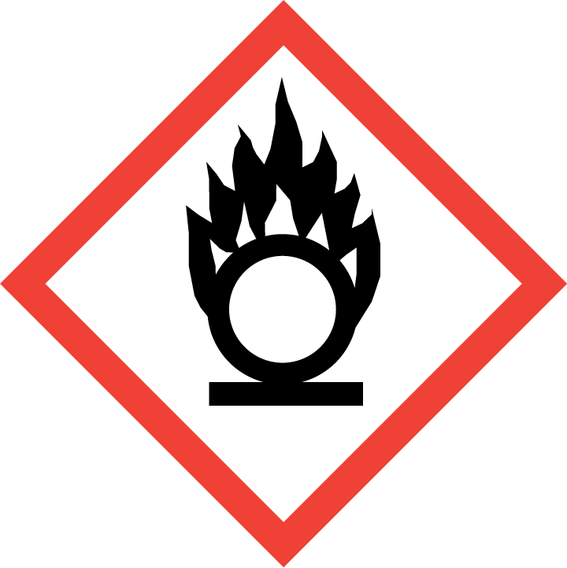 |  | Oxygen,
Class 2.3 Poisonous Gases | H280, H300, H310, H330 | 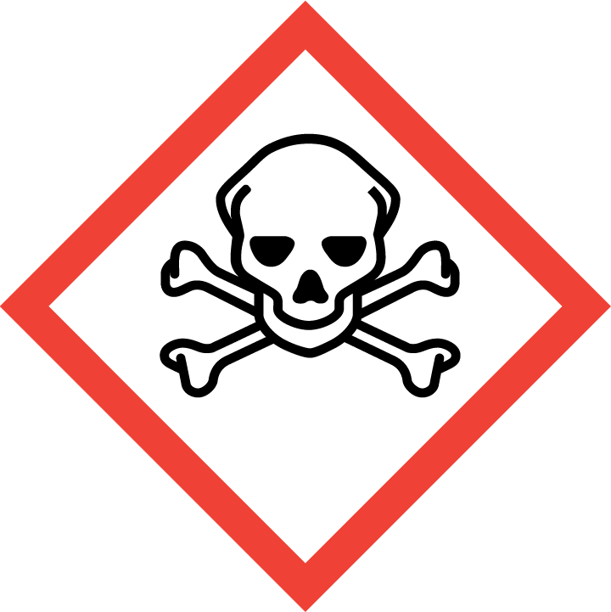 | 0.125 kg or 0.025m³ | Ammonia, Chlorine
Class 3 Flammable Liquids | H224, H225, H226 |  | 2.5 L | Ethanol, Acetone, Petrol, Kerosene, Diethyl Ether
Class 4.1 Flammable Solids, Self-Reactive Substance | H228, H240, H241, H242 | 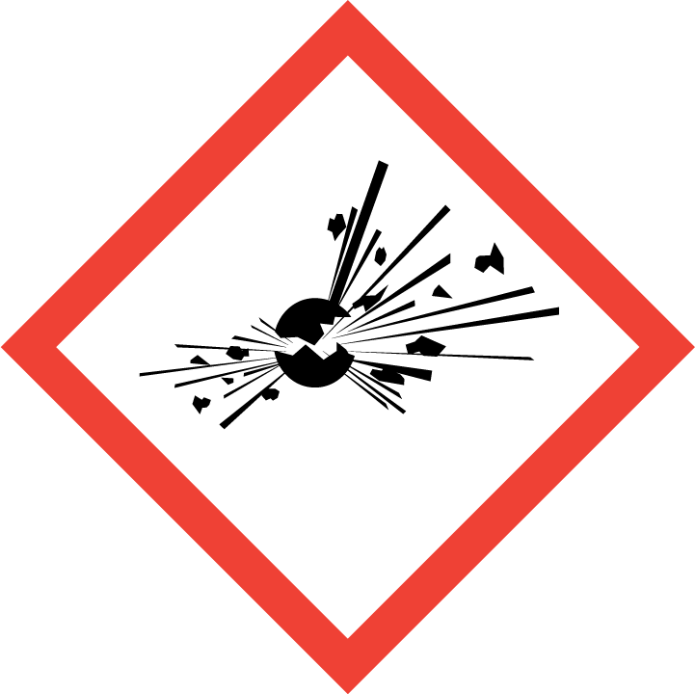 | 0.5 kg | Metaldehyde, Red Phosphorus, Nitrocellulose products, Sulphur, Magnesium, Picric Acid (wetted)
Class 4.2 Pyrophorics and Self heating substances | H250, H251, H252, |  | 0.25 L or 0.25 kg | Sodium Dithionite, Thiurea Dioxide, White Phosphorus, Yellow Phosphorus
Class 4.3 Substances Emitting Flammable Gases When Wet | H260, H261 |  | 0.25 L or 0.25 kg | Sodium, Calcium Carbide, Aluminium Phosphide
Class 5.1 Oxidising Agents | H271, H272 |  | 0.5 L or 0.5 kg | Ammonium Nitrate, Potassium Permanganate
Class 5.2 Organic Peroxides | H240, H241, H242 |  | 0.25 L or 0.25 kg | MEK Peroxide
Class 6.1 Toxic Substances | H300, H301, H310, H311, H330, H331, H334,  H340-H373 | 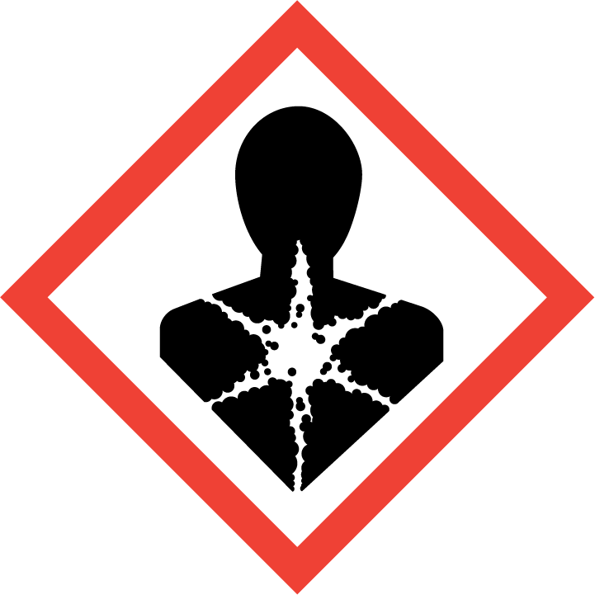 | 0.25 L or 0.25 kg | Some Pesticides, Some Drugs, Sodium Cyanide
Class 8 Corrosives | H314, H318 | 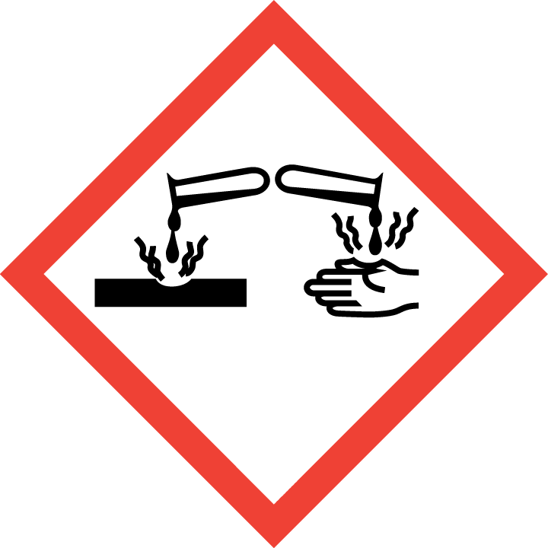 | 1.25 L or 1.25 kg | Acids, Alkalis
Provide details of chemicals used in large scale and include:
- Reasons why large amounts are required
- The processes the large scales will be used in
- Special control measures to be used to reduce associated risk
Any other chemical hazards that you wish to discuss?

SECTION 2: CONTROL MEASURES
Select and provide details of controls that will be used to reduce the overall risk:
☐ Has elimination of the activity been considered?
☐ Has substitution of a less hazardous chemical or activity been considered?
☐ Isolation & Engineering Controls
☐ Administrative Controls
☐ Personal Protective Equipment

Elimination and Substitution:
Were there any chemicals or high-risk activities able to be eliminated, or substituted with less hazardous alternatives?

Isolation and Engineering Controls:
Please select the controls that will be used:
☐ Fumehood
☐ Glove Box
☐ Other ventilation system (e.g. Snorkel extraction)
☐ Shielding
☐ Special storage conditions (e.g. under oil or inert gas)
☐ Other (please specify):

Administrative Controls

Unattended Experiment Declaration
You are required to place a completed ‘Unattended Experiment Form’ alongside any experiments which will be left for more than a few hours (e.g. overnight, weekends). High risk experiments must never be left unattended.
Tick the box to indicate that you have read and agree to this statement.
☐ I have read and agree with this statement.
Select the additional administrative controls that will be used:
☐ Controlled work area (e.g. restricted HF lab)
☐ Relevant inductions completed by all team members (IFM level 1 safety, Level 2 chemical induction, local area induction).
☐ Team members have completed/read all relevant local area procedures (Inductions, relevant SOP/SWP’s and risk assessments)
☐ Specific training for higher hazard processes or chemicals completed (e.g. HF lab). If yes, provide details.
☐ Environmental monitoring (contact the Health and Safety Team for more information)
☐ Health surveillance (contact the Health and Safety Team for more information)

☐ Other Administrative Controls? (Please specify)

Personal Protective Equipment (PPE):
Refer to the IFM Personal Protective Equipment Procedure for guidance on this section.
Please select the personal protective equipment that will be used:
Eye Protection
☐ Safety Glasses
☐ Safety Goggles
☐ Face shield
☐ Other (?)
Body Protection
☐ Lab Coat
☐ Lab gown
☐ Apron
☐ Other (?)
Hand Protection
☐ Gloves (Please specify type below)

Foot Protection
☐ Enclosed footwear
☐ Steel-cap boots
☐ Other (?)
Other Protection
☐ Respiratory protection (Please specify)
☐ Any additional PPE not listed above? (Please specify)

WSA: Plant, equipment and Physical Hazard

Section 1: Summary of plant & physical processes
Provide a brief summary of the plant and physical process aspects of the proposed work, using plain language with non-scientific terms.
Include plant or process to be used, location, frequency of use and likely hazards for participants, as well as previous experience if applicable)
Location(s) of physical work (include lab/workshop number or address if off-campus):
Routine Work: The work is best described as routine and has been previously assessed for hazards, there is a clearly defined procedure for the physical processes
☐ Yes. If yes, please upload these to your project folder on the WSA SharePoint site as supporting documentation.
☐ No. If non-routine work is planned an assessment of potential hazards is required, and a safe operating procedure is to be written and approved by the work supervisor prior to work commencing.

Section 2: Information about plant and physical processes

Hazardous Plant
- Hazardous Plant under OHS legislation is described as any plant that is power operated, fixed, and:
- Cuts, drills, punches or grinds material (e.g. LA Workshop equipment)
- Presses, forms, hammers, joins or moulds material ( eg Instron )
- Combines, mixes, sorts, packages, assembles, knits or weaves material (e.g. Welding, Molten Metal)
- Lifts or moves materials or people (e.g. forklift)
- Boilers, pressure vessels and explosive powered tools, furnaces, ovens
For more information about hazardous plant see the University OHS Manual.
*****
Is there Hazardous Plant to be used in this work?
☐ Yes, Hazardous Plant will be used – Provide details of Plant
Hazardous Plant name/description | Location
Is the work with hazardous plant best described as routine?
☐ Yes, all Hazardous Plant has been previously assessed for hazards the work is considered routine work and will follow an approved written procedure or SOP. If yes, please upload these to your project folder on the WSA SharePoint site as supporting documentation.
☐ No. If non-routine work is planned an assessment of potential hazards is required, and a safe operating procedure is to be written and approved by the work supervisor prior to work commencing
Will Hazardous Plant be modified in any way so that it will be used differently from its initial intended use? This includes removing or replacing guarding and processing material that is not normally used with this equipment
☐ Yes. If yes, please upload these to your project folder on the WSA SharePoint site as supporting documentation.
☐ No
Will any Hazardous Plant be designed, manufactured or supplied for use at Deakin or another workplace?
☐ Yes – There are additional requirements under OHS legislation. Contact the University Manager, OHS & Wellbeing for advice.
☐ No, Hazardous Plant will NOT be used

Hazardous Manual Handling & Physical Processes
Manual Handling means using your body to exert force to handle, support or restrain any object and includes not only lifting and carrying but also repetitive tasks.
A Hazardous Manual Handling Task is any manual handling task that has the potential to cause injury
(E.g. lifting heavy objects, repeated lifting of objects, etc.).
If manual handling is planned, an assessment of potential hazards and control measures to be used is required. A safe working procedure is to be written and approved by the work supervisor prior to work commencing.
(Note: Using Hazardous Plant is not necessarily Hazardous Manual handling unless there are additional manual handling hazards)
For more information about hazardous manual handling including risk assessment assistance, see the University OHS Manual.

Will the work involve hazardous manual handling tasks?
☐ Yes – Provide details of manual handling tasks. Indicate whether a risk assessment has been completed and if a safe working procedure is available.
Hazardous manual handling task (include location) | Risk assessment completed (Y/N) | Safe Working Procedure or JSA available (Y/N)

Upload procedures and or risk assessment to your project folder on the WSA SharePoint site as supporting documentation.
☐ No
Is your work going to generate any hazardous waste products, emit fumes, smoke or particulates?
☐ Yes – Provide details of waste generated and control and/or disposal method:
Description of hazardous waste generated | Controls used to manage waste | Safe Working Procedure Available (Y/N)
Upload procedures and or risk assessment to your project folder on the WSA SharePoint site as supporting documentation.
☐ No

Control measures
Identify and provide details of controls will be used other than those identified above to reduce the overall risk.
Elimination and Substitution | Details
Is it possible to eliminate the hazardous plant or activity?
Is it possible to substitute a less hazardous piece of equipment, material or activity?
Engineering and Isolation Controls
☐ Additional guarding fitted/used
☐ Air extraction system
☐ Safe lifting devices
☐ Other Engineering controls
Administrative Controls
☐ All participants are/will be trained in safe use of all Hazardous Plant. Provide date and location of training if applicable
Is further training required before work commences? | ☐ Yes ☐ No, previously completed
☐ Work procedures (e.g. work in office hours only, no remote work etc.). List procedures to be used
☐ Written Emergency Procedure (e.g. who to contact in case of accident, closest emergency facility). List procedures to be used
☐ Other Administrative controls
Personal Protective Equipment
☐ Any PPE additional to normal workshop or lab requirements (e.g. helmets, heat proof gloves, hearing protection, heatproof clothing)

WSA: Fieldwork & Off-Campus Activities

Section 1: Summary of off-campus aspects
Provide a brief summary of the off-campus aspects of the proposed work, using plain language with non-scientific terms.
Include typical duties, location, length of time off-campus and likely hazards for participants (as well as previous fieldwork experience/visits if applicable)
Location(s) of off-campus or overseas work (include address or nearest town/obvious landmark)

Section 2: Information about the off-campus activity

Field Work (includes Overseas work)
Will the off-campus work involve visits to the field (including overseas)?
☐ Yes – Complete following section to identify possible hazards and the control measures to be used which will reduce the risk associated with these hazards

Identification of hazardous locations
Will any work take place in or near:
- Aquatic locations (e.g. rivers, lakes, open water)?
- Remote locations (e.g. outside of reliable mobile phone coverage, more than 30 minutes from medical assistance)?
- Locations which are potentially exposed to extreme weather conditions (e.g. blizzards in alpine areas, desert locations, coastal conditions, poor visibility or heavy rain)?
- Other potentially hazardous situations (e.g. cliff faces, around machinery, at night)?

☐ Yes – Provide details of location, potential hazards that may be encountered and control measures to be used:
Location(s) | Potential hazards | Specific controls measures to be used
☐ No
Will any of the work take place overseas?
☐ Yes – Provide location, any local immunisation requirements and report-back procedure to be used:
Location(s)  incl. country | Immunisation requirements | Report-back procedure to be used

Note: (1) Advice should be sought from the Human Resources Division for advice on WorkCover and other Workers’ Compensation cover while overseas. For example, Workcover may apply for stays up to 6 months, however if the travel is a formal arrangement with work performed and paid for by another organisation, local Workers’ Compensation arrangements may apply (2) Travel Insurance and other advice is available from the Financial Services Division (3) Advice on Immunisation requirements can be sought from your family doctor or a Deakin Medical Centre
☐ No
Does the work location require any permissions or permits (e.g. private land, national parks)?
☐ Yes – Provide details of location and permission/permit required
Location | Type of Permit / Approval required | Permit / Approval obtained (Y/N, date)
☐ No

Identification of hazardous activities
Will the work involve extended drive-time to reach the site?
☐ Yes – Provide details of procedures/control measures to be used to reduce driver fatigue:
Note: If repeated long-distance driving is involved details of a typical drive are acceptable
Destination | Distance or Driving Time | Control measures to reduce driver fatigue
☐ No
Will the work involve the off-road use of a vehicle?
☐ Yes – Provide details of relevant 4-wheel drive experience or safety course:
Note: If using personal vehicles you must provide your own Insurance coverage. (Staff can refer to the Campus Services Division for policy on use of University vehicles)
☐ No
Will the work involve the use of a trailer?
☐ Yes – Provide details of relevant experience in ability to tow and reverse a trailer:
☐ No
Will the work involve the use of a boat?
☐ Yes – Provide details of boat to be used, Boat Licence, relevant boat-handling experience and safety measures employed to ensure personnel safety :
☐ No
Will the work involve handling of animals in the field (alive or dead)?
☐ Yes – An application must be made to the Animal Welfare Committee.
Refer to the Animal Ethics website.
☐ No
Will the work involve preserving samples in solvents other than ethanol?
☐ Yes – Provide details of solvents to be used, including any safe handling procedures required:
☐ No
Will the work involve any specialist techniques or equipment (e.g. net cannons)?
☐ Yes – Provide details of technique or equipment, associated hazards and specific control measures in place to minimise risk:
☐ No
Will the work involve overnight stays away from the University?
☐ Yes – Provide details of typical time away & report-back procedure to be used:
☐ No
Are there any other foreseeable hazardous activities which are not identified above?
☐ Yes – Provide details of activity, potential hazard and controls to be put in place:
☐ No

Work in areas controlled by other organisations
Will the off-campus work be performed at a location managed by another Organisation?
☐ Yes – Complete remainder of this section
Provide details of Organisation:
Name:
Organisation
Does the other Organisation have an adequate OH&S management system (including induction) in place? (A modified version of the Model Placement Proforma can be completed to assess this)
☐ Yes – Attach Placement Proforma, or provide other detail of OH&S management system in place
Notes: (1) Primary liability under the OHS Act lies with the occupier/manager of the actual workplace that staff may be working at. However in the event of an accident it is likely that the University would be involved in any investigation or prosecution and must be able to show that it has taken appropriate action to assess the safety of its workers. The Deakin manager/supervisor of the staff involved in the off-site work is responsible for carrying out this assessment before work commences. In the event that Deakin controls the off-site workplace, or is providing services outside the normal expertise of the other organisation, the University has the primary OHS responsibility to personnel from Deakin and the other organisation.(2) If the work involves biological, chemical, radiation, plant/physical or other hazards you must complete the relevant Hazard Assessment Form.
☐ No – Provide detail of why this is not required:

Section 3: Control measures
Identify and provide details of controls will be used other than those identified above to reduce the overall risk
Control Measures | Details
Elimination & Substitution
Has elimination of the location or activity been considered? ☐ Yes ☐ No
Has substitution of a less hazardous location or activity been considered? ☐ Yes ☐ No
Engineering Controls
☐ Radio communication, satellite phone, mobile phone or EPIRB unit
☐ Other Engineering controls
Administrative Controls
☐ Report-back procedure
☐ Off-campus activities questionnaire
☐ First Aid Kit
☐ Training in first aid
☐ Work procedures (e.g. working in pairs, contact with park rangers etc.). List procedures to be used and provide a copy
☐ Emergency procedures (e.g. who to contact in case of emergency, closest emergency facility). List procedures to be used and provide a copy.
☐ Pre-work reports accessed (e.g. marine or weather reports)
☐ Training previously completed, including field-work but not 4wd or boat training listed above. Provide date and location of training.
Is further training required before work commences? | ☐ Yes ☐ No, previously completed
☐ Other Administrative controls
Personal Protective Equipment
☐ Any PPE outside normal field or workplace requirements (e.g. helmets, gloves)

WSA: Biological Hazards

Section 1: Summary of biological aspects
Provide a brief summary of the biological aspects of the proposed work, using plain language with non-scientific terms. List biological materials to be used and potential biological hazards. This includes but is not limited to animals, plants, invertebrates, human tissues, blood and body fluids, soil, foodstuffs, water, effluents, pharmaceuticals, etc. If applicable, include experience with this type of work.
- Summarise your project
- What aspect of the work is considered biological or work with potentially biohazardous materials or processes?
- Are there standard or well documented procedures you can provide?
- Do you have experience with working with the relevant biological materials and techniques?
Room numbers where work is to be carried out? (Include support rooms such as autoclave rooms, cold rooms etc.)

Section 2: Classification of work

Work with biological materials
This includes work with animals, plants and invertebrates as well as human tissues, blood and body fluids and biological materials such as soil, foodstuffs, water, effluents, pharmaceuticals etc.
All work with microorganisms or with biological materials that have the potential to contain microorganisms should follow the requirements of the australian/new zealand standard for microbiological safety as/nzs 2243.3 (current version) safety in laboratories – part 3: microbiological safety and containment.
Does the work fall under the auspices of AS/NZS 2243.3 (current version)
☐ Yes
☐ No – State why
☐ Don’t know - Contact the Biosafety Team for advice
Has PC1/PC2 biosafety induction training been completed?
☐ No – go to Deakin biosafety induction training for more information and to register for an upcoming course
☐ Yes – complete training details below
Provide name of participant, date of training and results of assessment (quiz), for all persons working on this project.
 | Name | Date of Course | Quiz completed and Passed
1 |  |  | ☐ Yes ☐ No
2 |  |  | ☐ Yes ☐ No
3 |  |  | ☐ Yes ☐ No

Work involving genetic modification
Does the work involve the use of genetically modified organisms or any genes or materials that have been genetically modified?
☐ Yes – continue to next question
☐ No – skip to Biosecurity
All work with genetically modified organisms or genes or materials that have been genetically modified is regulated by the Office of the Gene Technology Regulator (OGTR).
Refer to the OGTR website (dealings) to determine the type of dealing and tick the appropriate box below:
☐ Exempt
☐ NLRD
☐ DNIR
☐ DIR
As applicable, complete the Exempt Dealing, NLRD or DNIR application form available from the Biosafety and Biosecurity website and submit it to the Laboratory & Biosafety Committee.

Reference Number as provided by LBC (e.g. 3/2011): | /

If unsure about the type of dealing, contact the Biosafety Team for advice.
The category of the dealing will determine the containment level of OGTR certified facility required. Indicate below the type and level to be used (Contact the Biosafety Team for assistance):
Type of facility: ☐ laboratory animal ☐ plant ☐ invertebrate ☐ aquatic
Level of facility: Exempt Dealings: ☐ PC1
NLRD Dealings: ☐ PC1 or ☐ PC2
DNIR Dealings: ☐ PC2 or ☐ PC3
Certification number and year: | /

Relevant OGTR Facility Guidelines must be followed for each of the above categories.
Have all participants completed training in the OGTR Behavioural Requirements?
☐ No – contact the LBC Secretary for enrolment in an upcoming course
☐ Yes – complete training details below
Training details- Give name of participant and date of training:
1.
2.
3.

Biosecurity
Does the work involve the use of materials imported into Australia?
Refer to Department of Agriculture, Water and the Environment (DAWE) website (Biosecurity Import Conditions System (BICON) for assistance. If unsure, contact the Biosafety Team for advice.
☐ No – go to Security Sensitive Biological Agents
☐ Yes
Is there an existing DAWE (AQIS) Import Permit to cover this work?
☐ No - refer to DAWE Import Information and complete Import Permit application
☐ Yes
Please provide the Import Permit No:
Permit N:

Work with imported biological materials may need to be carried out in a DAWE Approved Arrangement - AA (formally Quarantine Approved Premise).

Note: Relevant DAWE AA requirements must be followed for this work.
Is there a requirement for the work to be carried out in a DAWE AA? (refer to AA information or your DAWE Import Permit)
☐ No – go to Security Sensitive Biological Agents
☐ Yes - Give type, level and Approval Number of AA where the work will be carried out:
Type of facility: ☐ laboratory animal ☐ plant ☐ invertebrate ☐ aquatic
Level of facility: BC1 ☐ BC2 ☐
Approval number: | AA

Relevant DAWE AA requirements must be followed for this work.
Have all participants successfully completed on-line training to become an AA Accredited Person?
☐ Yes – forward a copy of certificate to the Biosafety Team
☐ No - refer to AA accreditation and complete the on-line course then complete training details below.
Give name of participant and date of training:
1.
2.
3.

Security Sensitive Biological Agents
Work with specific microorganisms and toxins (called Security Sensitive Biological Agents, [SSBAs]) is regulated by the Department of Health (DoH).
Does the work involve the use of microorganisms or toxins listed as Tier 1 or 2 agents in the Department of Health legislation?
☐ No
☐ Yes - List the microorganisms or toxins here and contact the Biosafety Team for advice:
1.
2.
3.

SECTION 3: Identification of hazards

Biological materials
Identify the hazards or potential hazards associated with this work and provide information. Write N/A if not applicable.
If working with microorganisms, list all cultures to be used, including their Risk Group (Refer to AS/NZS 2243.3). List the risks and hazards associated with the cultures. Attach the certificates as supporting documents as well as their PSDS or other useful resources for identifying and understanding the hazards when working with them.

Culture name and Reference number | Risk Group | Routes of exposure | Possible of infections / Pathogenicity
List all human and animal tissues, cells and fluids, and other biological materials (e.g. soil) used, including Risk Group (Refer to AS/NZS 2243.3). Consider the potential hazards for samples or materials to be used e.g. animal tissue samples, purified protein, serums, etc.
Note: Section 3 of the standard, AS/NZS 2243.3, describes how to determine the degree of risk posed by microorganisms and how they are classified into levels called Risk Groups. Determine how materials used in your project fit with the Risk Grouping and what level of individual and community risk they pose. Once known, the Risk Group indicates the level of physical containment (PC) required to safely handle your materials.
E.g. work involving human tissues and blood, which have the potential to contain blood borne pathogens (such as Hepatitis B virus, a Risk Group 2 microorganism) and must be handled and stored under PC2 conditions; wastewater and compost samples harbour communities of pathogenic and non-pathogenic organisms that can cause infections in humans. Consider the potential hazards for samples or materials to be used e.g. animal tissue samples, purified protein, serums, etc.
Biological material | Risk Group | Potential microbiological hazards

List animals, birds or fish used
If using animals or collecting samples from animals, what species will be used during the work?
Animal including species | Risk Group | Potential microbiological hazards

Procedural hazards
List procedures used that have the potential to generate infectious aerosols (e.g. aspiration, shaking, vigorous pipetting, grinding/blending, vortexing, sonication, freeze-drying, centrifugation etc.). Attach SWP’s/SOPs.
Provide context of the hazards to the proposed project work. Attach or provide links where possible.
Incorrect use of sharps is a frequent cause of incidents in biological labs. List procedures where sharps are used and attach Sharps SWP/SOP

Overuse injuries can occur with frequent use of Biological Safety Cabinets. If used indicate cabinet use in hours per day or per week per person

Other hazards
List and provide information on any other identified biological hazards associated with this work

SECTION 4: Control measures
Identify and provide details of controls that are or will be put in place to reduce the overall risk level.
Select and provide details of controls that will be used to reduce the overall risk:
☐ Has elimination of the activity been considered?
☐ Has substitution of a less hazardous chemical or activity been considered?
☐ Isolation & Engineering Controls
☐ Administrative Controls
☐ Personal Protective Equipment

Elimination and Substitution:
Were there any biological hazards or high-risk activities been able to be eliminated, or substituted with less hazardous alternatives, such as materials or techniques? eg vaccine strain instead of normal strain, substitution of microorganism with one not infectious to humans?

Engineering controls
List all equipment used to contain infectious aerosols and prevent cross contamination of work (e.g. BSC II)
Describe type and location of storage of biological materials and security measures. State if these are located within containment facilities or external to them (e.g. locked fridge in ng1.002, external to containment facility)

Other engineering controls

Administrative controls
List procedures used for treatment, storage and disposal of infectious waste (i.e. disinfection / sterilisation procedures, including types of disinfectants). Attach SWP/SOPs
Talk to tech staff for additional information.

List relevant Laboratory Safety Manuals, Australian Standards and/or other SWP/SOPs referenced for work with biological materials

List emergency SWPs/SOPs to be followed in the event of a microbiological spill and attach a copy
List additional training and inductions to that detailed above in Section 2: Classification Of Work (e.g. microbiological spill training). Include location and date of training
Provide details
Training / Induction | Location | Date | Provider

List immunisations, if any, recommended to undertake this work
The Australian Immunisation Handbook and Victorian Department of Health and Human Services should be referred for current recommendations. Work with animals, providing healthcare or handling blood, tissues, and body fluids pose an elevated risk of exposure to pathogenic microorganisms.

List controls (entry restrictions, warning signs etc.) in Lab/Storage/ Work areas

Personal Protective Equipment (PPE):
List any PPE requirements (i.e. glasses, lab coat, protective footwear)
Refer to the IFM Personal Protective Equipment Procedure for guidance on this section.
Please select the personal protective equipment that will be used:
Eye Protection
☐ Safety Glasses
☐ Safety Goggles
☐ Face shield
☐ Other (?)
Body Protection
☐ Lab Coat
☐ Lab gown
☐ Apron
☐ Other (?)
Hand Protection
☐ Gloves (Please specify type below)
Foot Protection
☐ Enclosed footwear
☐ Steel-cap boots
☐ Other (?)
Other Protection
☐ Respiratory protection (Please specify)
☐ Any additional PPE not listed above? (Please specify)

Biological Safety Contacts
University Contact | Faculty / School / Division | Phone/Email
Deakin Biosafety & Biosecurity Officer | Deakin Research | biosafety@deakin.edu.au
Area Contacts
Matthew Connolly | SEBE OHS Manager | Matthew.connolly@deakin.edu.au

WSA: Radiation Hazards

Section 1: Summary of radiation aspects
Provide a brief summary of the radiation aspects of the proposed work, using plain language with non-scientific terms. (Include source of radiation, tasks to be performed and potential exposure times as well as previous experience with radiation if applicable)

Section 2: Information about the radiation source

Sealed or unsealed radiation source
A sealed or unsealed radiation source is radioactive material which emits ionising radiation and is either encapsulated or not.
Does the project involve the use of a sealed or unsealed radiation source?
☐ Yes - Complete remainder of this section
Note: It is strongly recommended that the University Radiation Management Plan be consulted when completing this section. It can be accessed at the Radiation safety webpage.
Details of the radiation source(s) to be used in the project:
Radionuclide
(e.g. C-14) Radiation type emitted
(e.g. gamma) Chemical form
(e.g. labelled thymidine) Activity used per procedure
(e.g. 100kBq)
List rooms where work with radiation will take place. Indicate if it is a dedicated radiation facility.
For work outside of dedicated radiation facilities:
Is a dedicated (marked) work bench available for radiation work?
☐ Yes
☐ No
Is a dedicated (marked) fume cupboard available for radiation work?
☐ Yes
☐ No
Describe the facility used to store radionuclides. Include shielding and security measures, and proximity to work area.
Provide details of proposed waste disposal procedure. Include anticipated physical and chemical form, estimated volume and activity upon disposal and waste storage arrangements.
(Provide the RSO with a copy of procedure if available).

Note: Information regarding dose estimation is available on the Radiation safety webpage or
contact the RSO.

rso to complete
Are the radionuclides registered and within limits allocated in the Department of Health Management Licence for this group/area?
☐ Yes
☐ No
If undergraduate or postgraduate students are using radiation is a Use Licence held by a supervising staff member?
☐ Yes
☐ No
☐ N/A
Use Licence holder(s):
☐ No

Ionising radiation apparatus
Ionising radiation apparatus are pieces of equipment which produce ionising radiation, commonly in the form of X-rays.
Does the project involve the use of any ionising radiation apparatus, other than an X-ray diffraction unit?
☐ Yes - Complete remainder of this section
Notes:
1. It is strongly recommended that the University Radiation Management Plan be consulted when completing this section. It can be accessed at the Radiation safety webpage.
2. The X-ray diffraction units currently held at Deakin are fully interlocked and monitored with very low risk of exposure. This form does not need to be completed by XRD users.
Provide details of the type of irradiating apparatus to be used.
Apparatus | Make and Model Numbers | Serial Number | Energy Range

RSO to complete
Is the apparatus registered on the University Radiation Management Licence?
☐ Yes
☐ No
Do all staff members listed as participants who will use the ionising radiation apparatus hold a current Use licence with the Victorian Department of Health?
☐ Yes – List Use Licences holders:
☐ No - see the Department of Health website (Use Licences) for information about obtaining a licence.
If unsure about requirements contact the Radiation Safety Officer.

Note: Undergraduate and Postgraduate students who use ionising radiation apparatus are exempt from the requirement to hold a Use Licence with the Victorian Department of Health with the condition that they are supervised by a person holding a Use Licence.
Does the work involve radiation exposure to human participants?
☐ Yes
The project must be assessed by the Human Research Ethics Committee. See the Radiation Safety webpage for more detail.
If human exposure is involved, the following documents should be provided to the RSO along with this form to expedite approval. Indicate if attached:
☐ DUHREC Ionising Radiation Supplement (approved by a Medical Physicist)
☐ Dose assessment provided by Medical Physicist
☐ No

Laser
Does the project involve the use of a Class 3R, 3B or 4 Laser where the beam is unguarded?
☐ Yes - Complete remainder of this section
Provide details of the laser(s) to be used.
Laser description | Location | Laser Class | Emission wavelengths
☐ No

RSO to complete
Has a laser hazard assessment been performed for the Class 3A, 3B or 4 laser?
☐ Yes
☐ No
☐ N/A
Are user eye tests recommended prior to using this laser?
☐ Yes
☐ No
☐ N/A

UV radiation
Does the project involve the use of UV radiation (in the range 10 - 400nm)?
☐ Yes - Complete remainder of this section
Provide details of the UV source
Apparatus | Make & Model | Wavelength(s)(nm) | Spectral irradiance (W/m2)
☐ No
Estimate the maximum exposure time to UV radiation from the above source in any single day (minutes):

RSO to complete
Refer to ARPANSA publication: Radiation Protection Series No. 12.
Will total radiant exposure exceed the limit for:
The unprotected eye:
☐ Yes
☐ No
Unprotected skin:
☐ Yes
☐ No

Strong Magnetic Field
Does the project involve the use of a strong magnetic field (excluding nmr)?
☐ Yes - Complete remainder of this section
Provide details of the magnetic field
Apparatus | Make & Model | Field Strength (tesla) | Alternating field? (Y/N)
☐ No

Other radiation hazard
Are there radiation hazards in the work not identified in sections above?
☐ Yes - Complete remainder of this section
Provide details of the radiation source and potential exposures:
☐ No

Section 3: Control measures
Identify and provide details of controls that are or will be put in place to reduce the overall risk level
Control Measures | Details
Elimination & Substitution
Has elimination of the hazard been considered?
☐ Yes ☐ No
Has substitution of the hazard for a less hazardous material or technique been considered?
☐ Yes ☐ No
Engineering Controls
☐ Shielding/ protective housing
☐ Interlocks
☐ Fume cupboard/glove box
☐ Other engineering controls
Administrative Controls
☐ Personal monitoring devices (e.g. TLD badges). List all participants allocated a device
☐ Area contamination monitoring. Describe procedure and frequency (provide SOP if available)
☐ Spill and Emergency procedures. List procedures to be used (provide a copy if available)
☐ Warning Signs on Lab/Storage/ Work areas
☐ Controlled area
☐ Training previously completed. Provide date and location of training
Is training required before work commences? | ☐ Yes ☐ No, previously completed
☐ Other administrative control
Personal Protective Equipment Details
☐ Any PPE outside of normal lab requirements (i.e. glasses, lab coat, protective footwear)

Section 4: Safety Officer Approval
Local Officer responsible for Radiation safety
Comments and Conditions
I believe so far as is practicable that the radiation hazards described for this work have been fully identified, and that the controls implemented are adequate to minimise risk as much as possible.
Name:
Position Title:
Signature:
Date:

Deakin University Radiation Safety Officer Approval (mandatory for all radiation work).
Comments and Conditions
I believe so far as is practicable that the radiation hazards described for this work have been fully identified, and that the controls implemented are adequate to minimise risk as much as possible.
Name:
Signature:
Date:

SEBE Safety Manager

WSA: Nanomaterials
Before completing this form, you should have completed the Nanomaterial Risk Level Banding
This form is for work with nanomaterials identified as:
- RL3 or RL4
- Elevated Risk RL1 or RL2.

Nanomaterial name

Work steps overview
Complete a flow diagram of work to be conducted indicating:
- Any potential points of personal exposure to nanomaterials
- Processes to be carried out (e.g. drying, aerosol production, heating, fumes, vessel transfer, collection, cleaning steps).
Start from purchase or synthesis through to disposal and cleaning.
Add text here if it helps to explain the flow diagram:

What type of nanomaterials will be used and how much will be handled daily?
Nanomaterials manufactured, supplied or used |  | Physical State |  |  |  | Quantity handled daily |  |  |  |  | Major Handling Operation
 | Nanomaterial details  (substance type, e.g. TiO₂, ZnO, or boron nitride nanotubes) | Dry powder | Suspension or liquid | Embedded or bound in other materials | Other | <1mg | 1mg to 1g | 1g to 1kg | >1kg | Manufacture or modify |  | Supply | Use
Carbon nanotubes
Quantum dots
Nano-powders
Colloidal dispersions
Fullerenes
Polymers
Nanowires
Nano-crystals
Carbon black
Dendrimers
Nanorods
Other nanotubes
Hybrid nanomaterial
Others (please describe)

Nanomaterial forms
 | Material  (e.g. TiO₂) | Form of material  (e.g. nanoparticles (powders), micro-sized particles (powders), nanoparticles in suspensions or colloidal dispersions, or nanoparticles embedded or bound in other materials) | Description of storage system and conditions,  (e.g. type of container, environment, etc.) | Waste Management Plan  (e.g. disposal method, dissolution or embedding, waste stream, etc.)
Raw materials (materials as supplied)
Manufactured intermediates
(if any)
Final product

Processes to be used
What operating activities does the work with nanomaterials involve? | Details of processes you will use for nanomaterials (e.g. type of transport, or type of particle analysis) | Details on how workers perform the activity
 |  | Number of workers involved | Frequency of activity | Duration of activity
Handling/transfer
Transport
Mixing/blending/formulating
Coating
Cutting/grinding/polishing
Storage/disposal
Maintenance operations
Particle analysis
Other (please describe)

Controls used to prevent exposure of persons to nanomaterials and other risk management procedures
What controls will be used? (Please complete all relevant boxes)
Details of the controls used (e.g. the type of equipment, procedures or standards used)
Include N/A if not relevant
Equipment design or redesign

Nanomaterial modification/substitution (e.g. change in chemical, or change in form such as from powder to paste)

Enclosure of process / Isolation of work from people

Fume cupboards/fume hoods
Cytotoxic and Class II Biohazard Safety hoods
What controls will be used? Cont.
Details of the controls used (e.g. the type of equipment, procedures or standards used)
Include N/A if not relevant
Other types of local exhaust ventilation (LEV) or extraction

Are High Efficiency Particulate Air (HEPA) filters used in any extraction systems associated with the controls above?
(e.g. do the fumehoods have a HEPA filter?)
Indicate ‘Not sure’ if unconfirmed
Administrative approaches
(e.g. Standard Operating Procedure (SOP), Safe Work Instruction (SWI), limiting access to work areas, or methods for equipment maintenance, cleaning up of spills or material disposal)

Prevention of nanomaterials spreading out of work area
(e.g. on clothing, shoes, or into other work areas and processes)

Training and induction regarding nanomaterial hazards
(Deakin nanosafety training is mandatory for all workers)
Indicate here if there is any additional nanosafety-related training to be provided
Use of personal protective equipment (PPE)
(e.g. gloves, other clothing, respirators, masks, safety glasses/goggles)

Training on fit checking and fit testing of respirators

Monitoring of work environment for nanomaterials
(Seek advice from Lab Managers if required)
Health surveillance
(Seek advice from Deakin OH&S)
Other (please describe)

Office Use Only
Submission received (date):
Documents reviewed and sent to following NSC members:
Application status: Approved / Returned for clarification / Rejected
NSC Chair notified of review outcome (date):
Principal Researcher, Project Supervisor and Technical Manager notified of outcome (date):

